# DASHBOARD README

## About the Project

This project will use the CRUD Python Module and the Dash Python Framework to create an interactive display of data charts based on the information provided by Austin Animal Center. The user will be able to quickly filter the database according to what is needed and visualize the different available breeds in a pie chart and the geolocation of the animal selected.

## Functionality

This dashboard is meant to be used to quickly identify and categorize animals that are best fit for specific types of training. The first function can be achieved by simply clicking on the logo of Grazioso Salvare, which would redirect the user to the SNHU home page. The code is flexible so the URL can be updated to any other one.

Below, there are three different charts that interact with the user selections:

The Data Table contains quick filtering buttons at the top which interact with the table and other graphs. Other properties such as column and row highlight are included as well as sorting and filtering by parameter.

The Pie Chart helps visualize the data presented after one of the filtering buttons has been selected. Initially, or after selecting “Reset”, the graph slices will be based on the type of animal present in the dataset as default (visualizing all breeds would then present a graph with very little significance, so this option was not considered for the whole dataset). Whenever any other filtering button is selected, the pie chart will show the different breeds available in the dataset that satisfy the requirements for a certain type of rescue training.

The Geolocation chart pinpoints the location of a selected animal in a map, as well as showing the breed of the animal and its name (if any). Responds to the selected row in the Data Table.

**First state of the dashboard:**

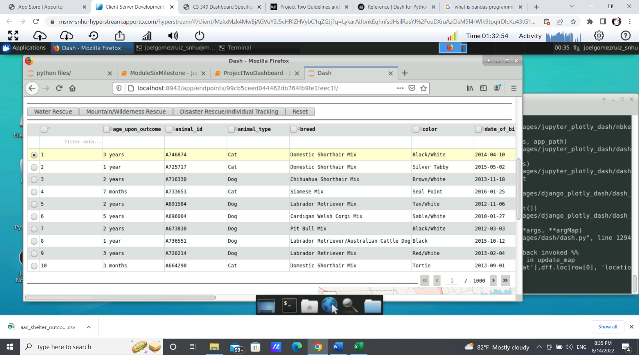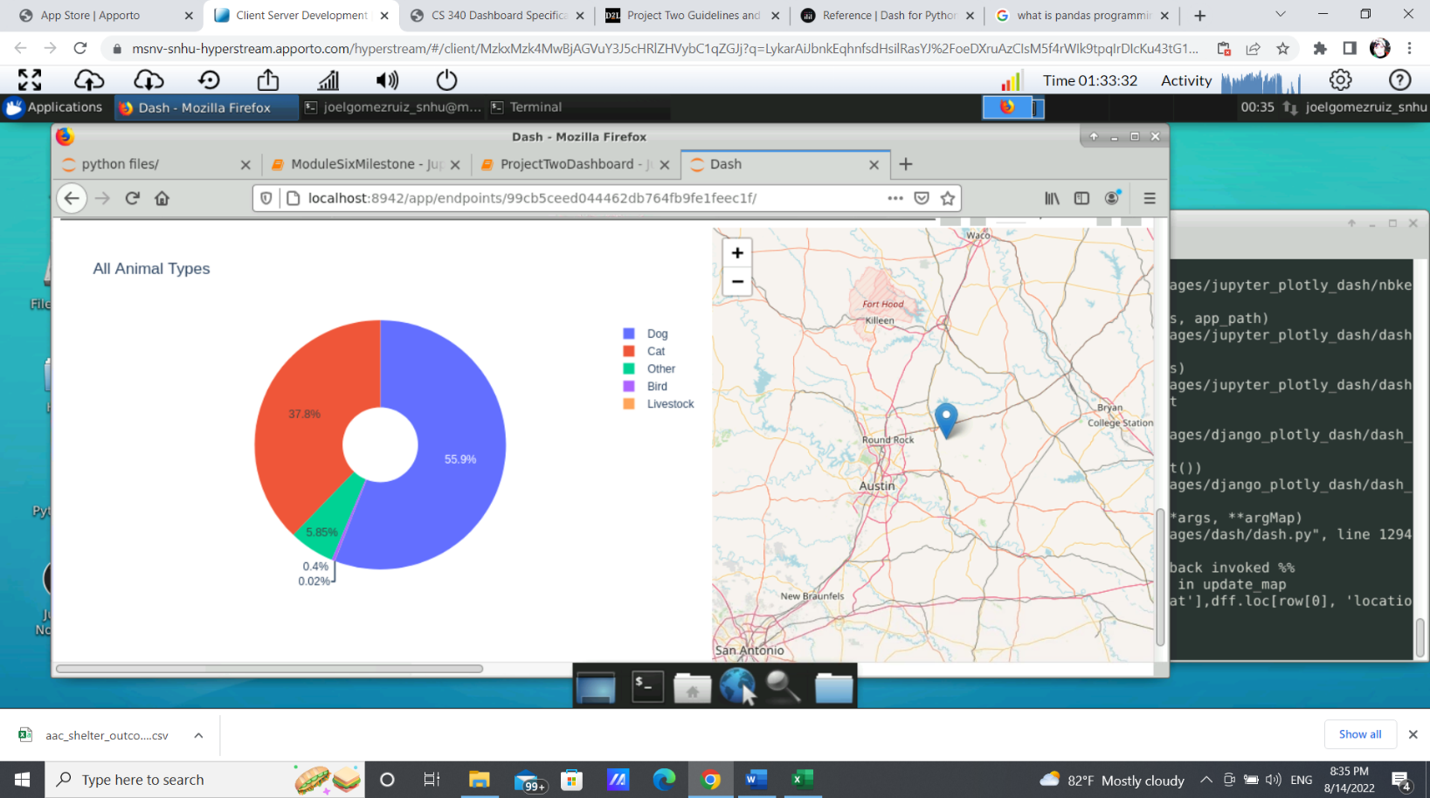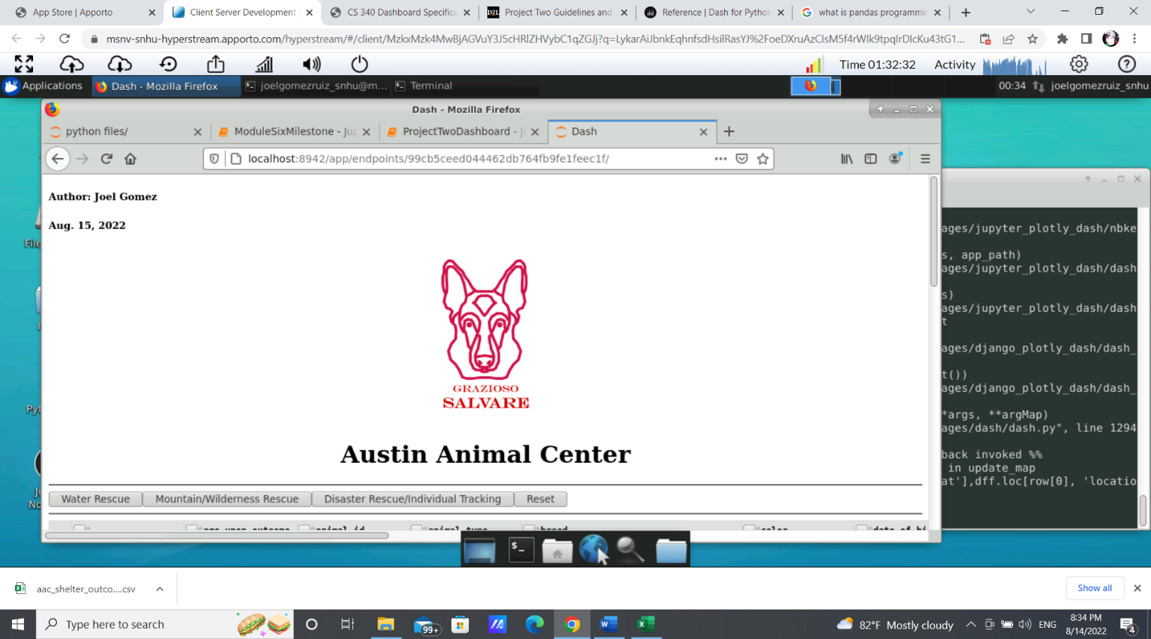

**Executions:**

Water Rescue Button:

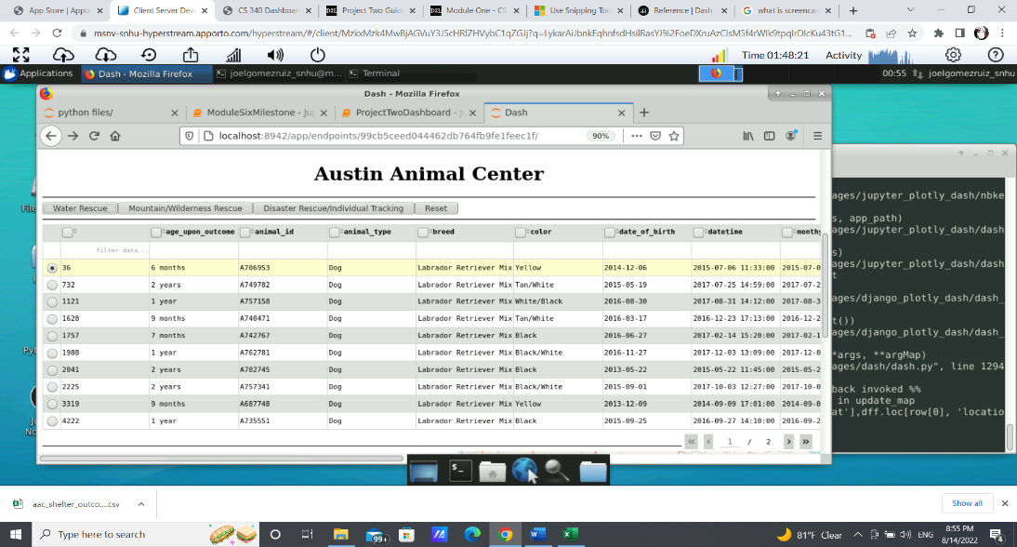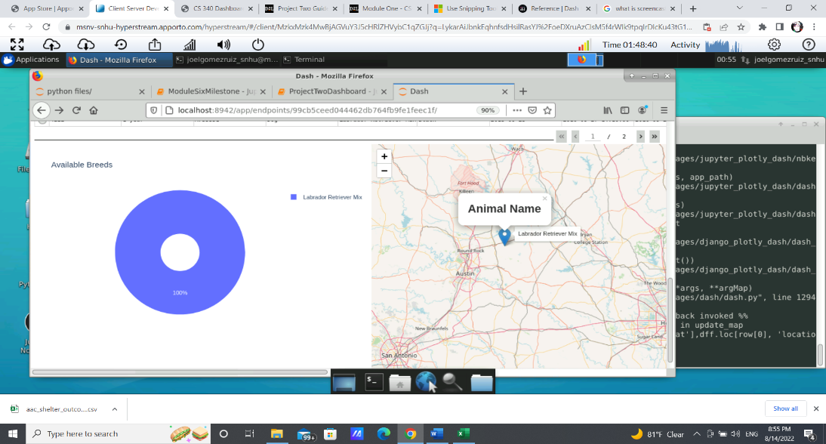

Mountain Rescue Button:

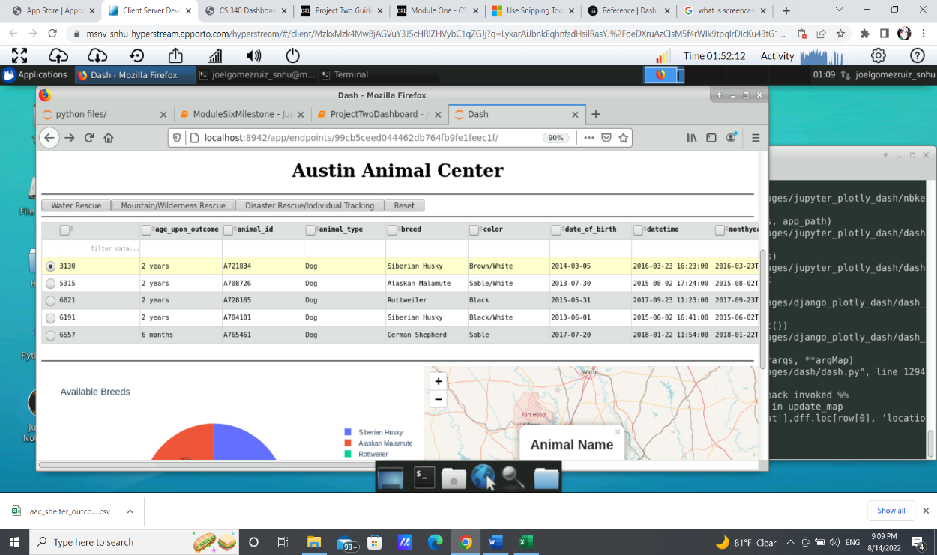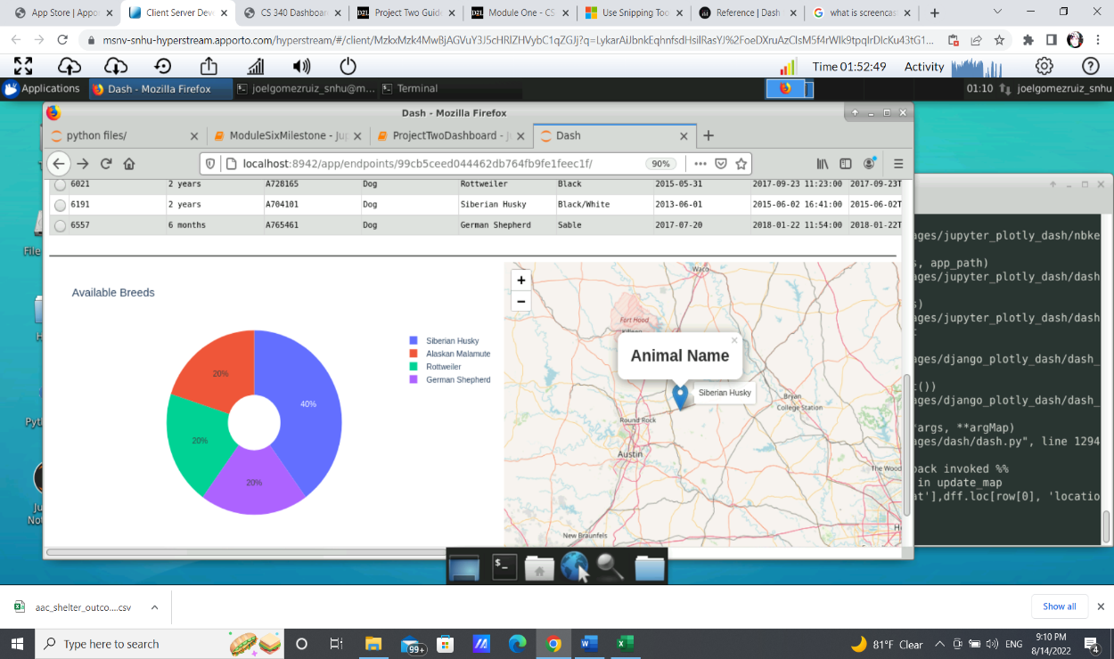

Disaster Rescue

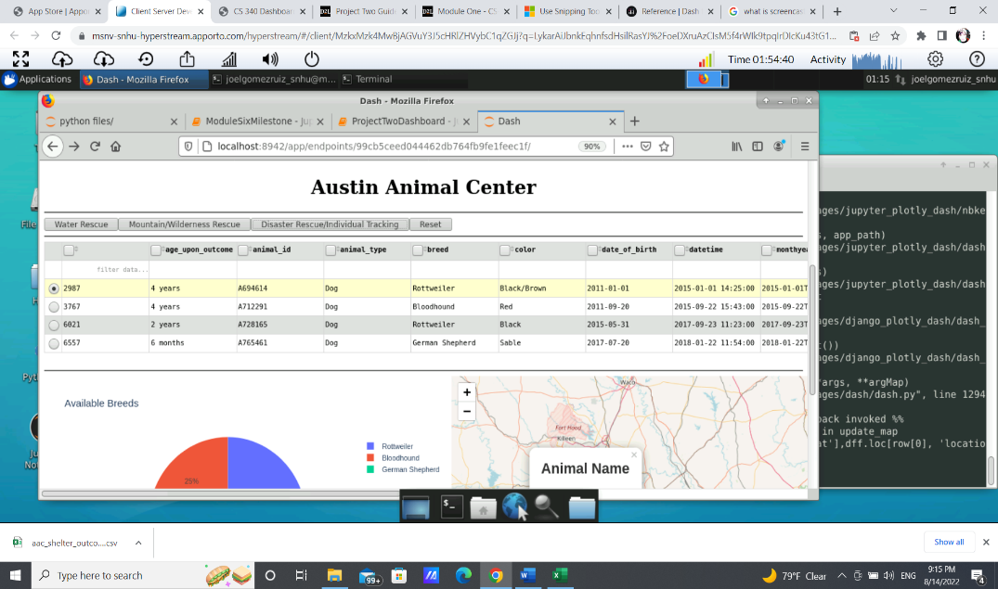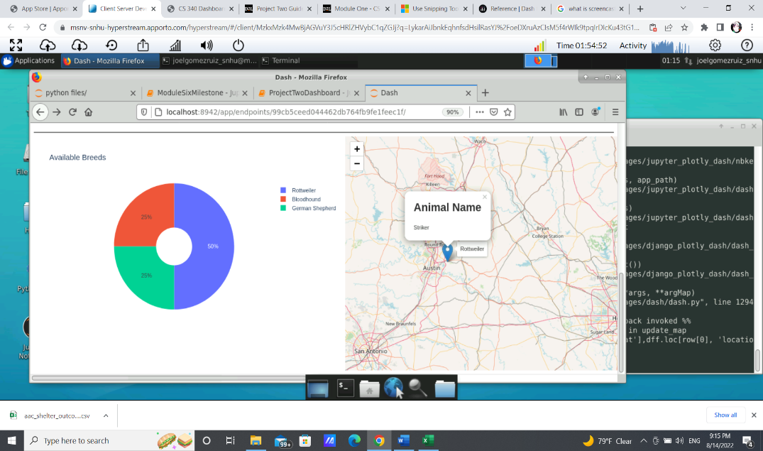

Reset

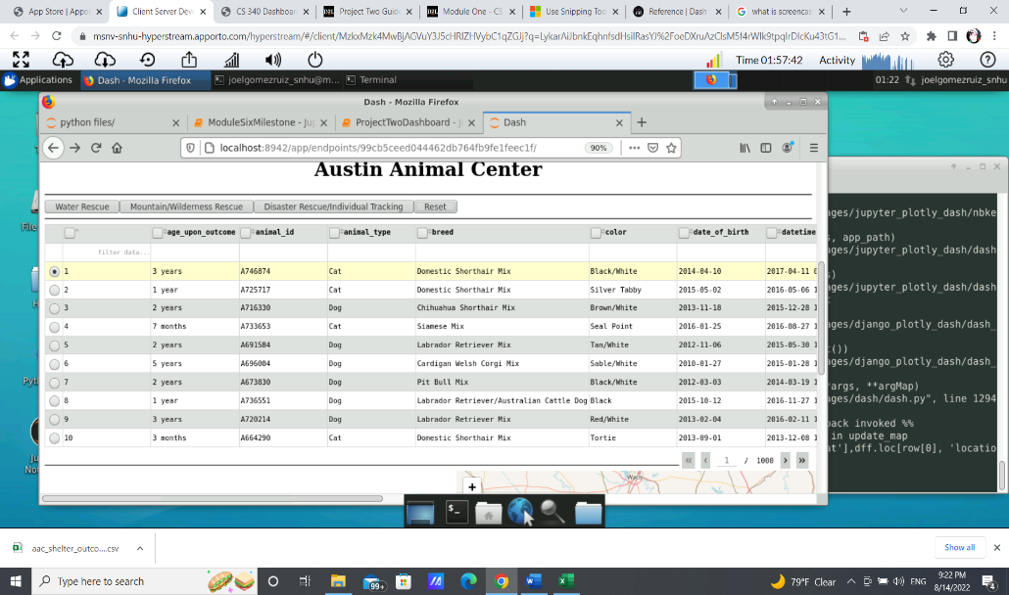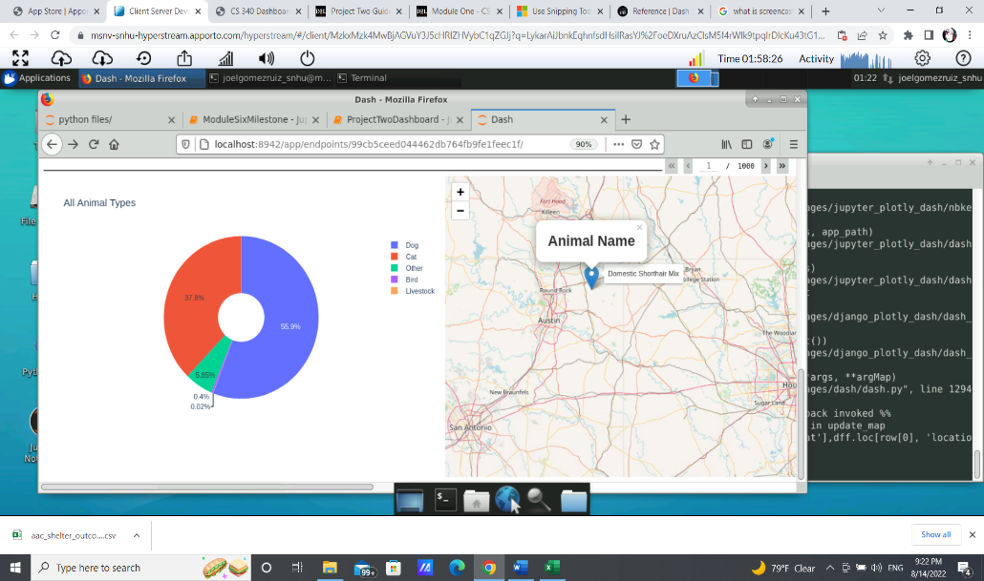

**Geolocation dynamic update:**

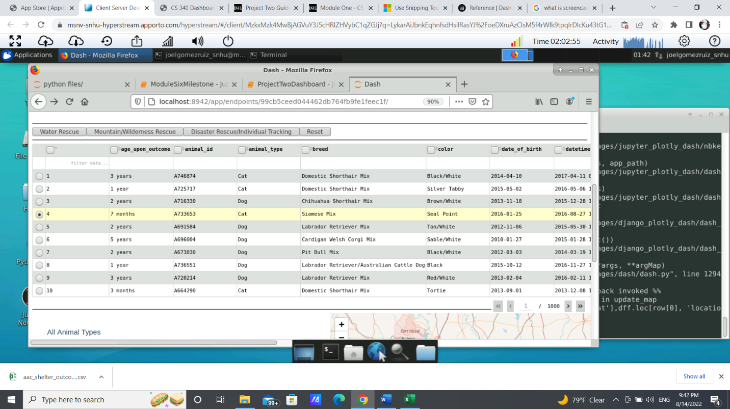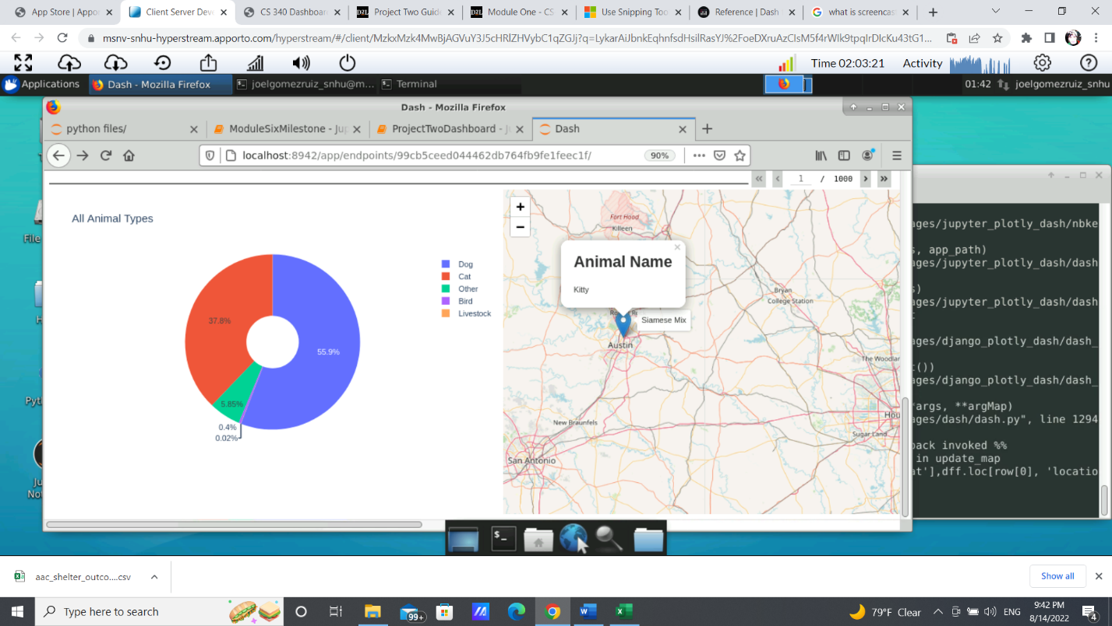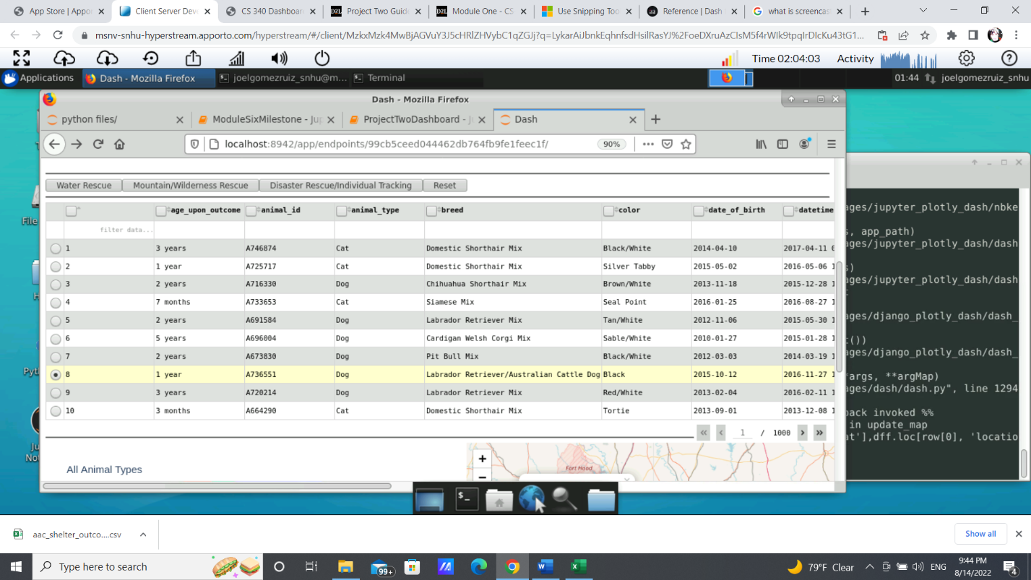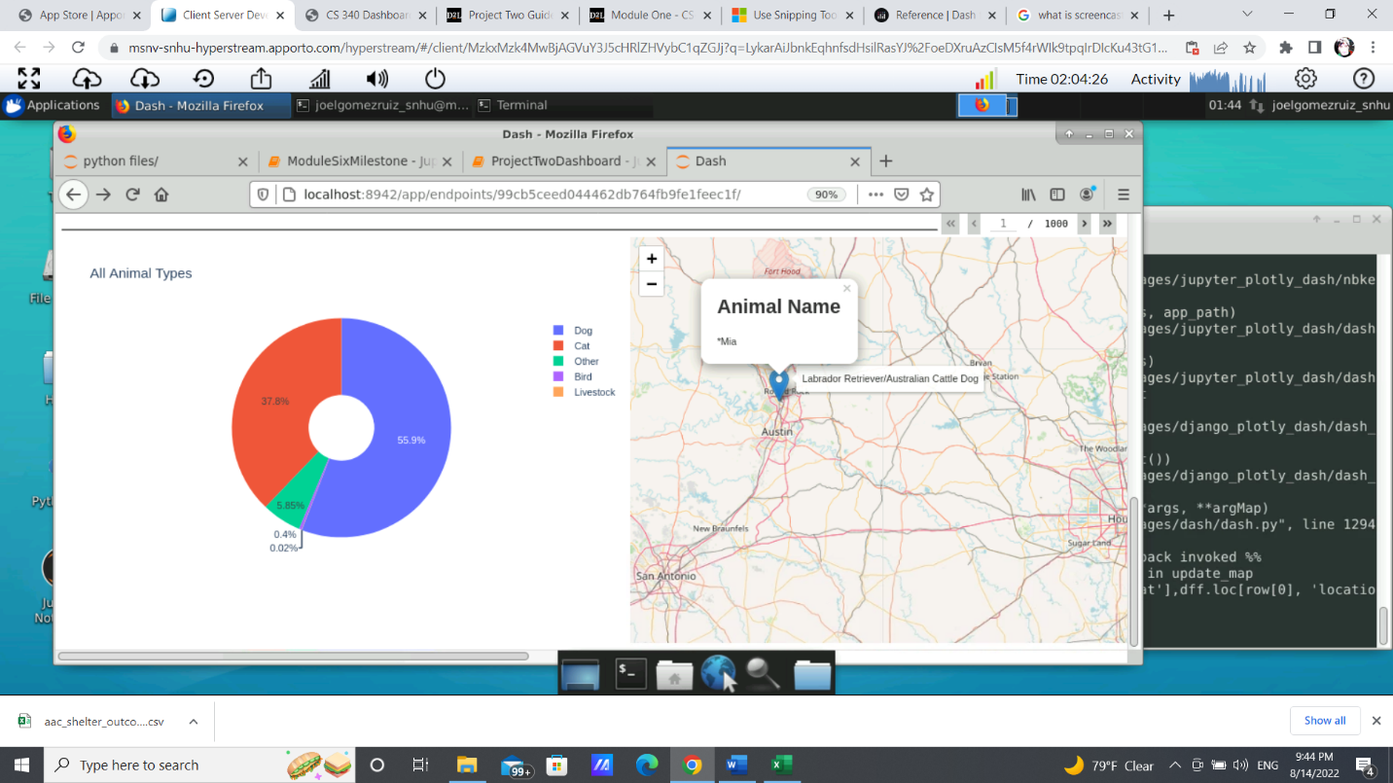

## Tools

Similar to the CRUD Python module, this dashboard was created using the JupyterNotebook platform, accessible through the terminal if Anaconda is already installed in the system. In order to properly use the dashboard functionalities, it is important that the database is already added to MongoDB and a user has been created. Refer to the CRUD Python Module to complete this step, as this code was created with the assumption that the CRUD Python Module was properly implemented.

MongoDB was used to collect and manipulate the database provided by Austin Animal Center, it was chosen for its flexibility, its capability to store large amounts of data and how it can interact with other languages such as Python. To enable that, the Pymongo package was needed in the creation of the CRUD module and once again was needed to create a MongoClient and access the database.

The Dash Framework was also the main tool used in this dashboard, this framework helped create the web application, allowing interactivity as it can be responsive according to user input. This package was needed to create the layout of the web application, set certain properties such as size, font and color, and determine the different elements present on the page, as well as all the different behaviors of certain selections.

Pandas was also an important tool in the creation of this dashboard as it helped manipulating the database into a data frame that could be easily displayed on the screen as a table.

**Installation**

In order to reproduce this project, it is important to import all the needed libraries and components that would make the creation of this dashboard more easily. It is important to know that while these libraries were needed, this project is not limited to what is provided and adding more functionality would require additional libraries:

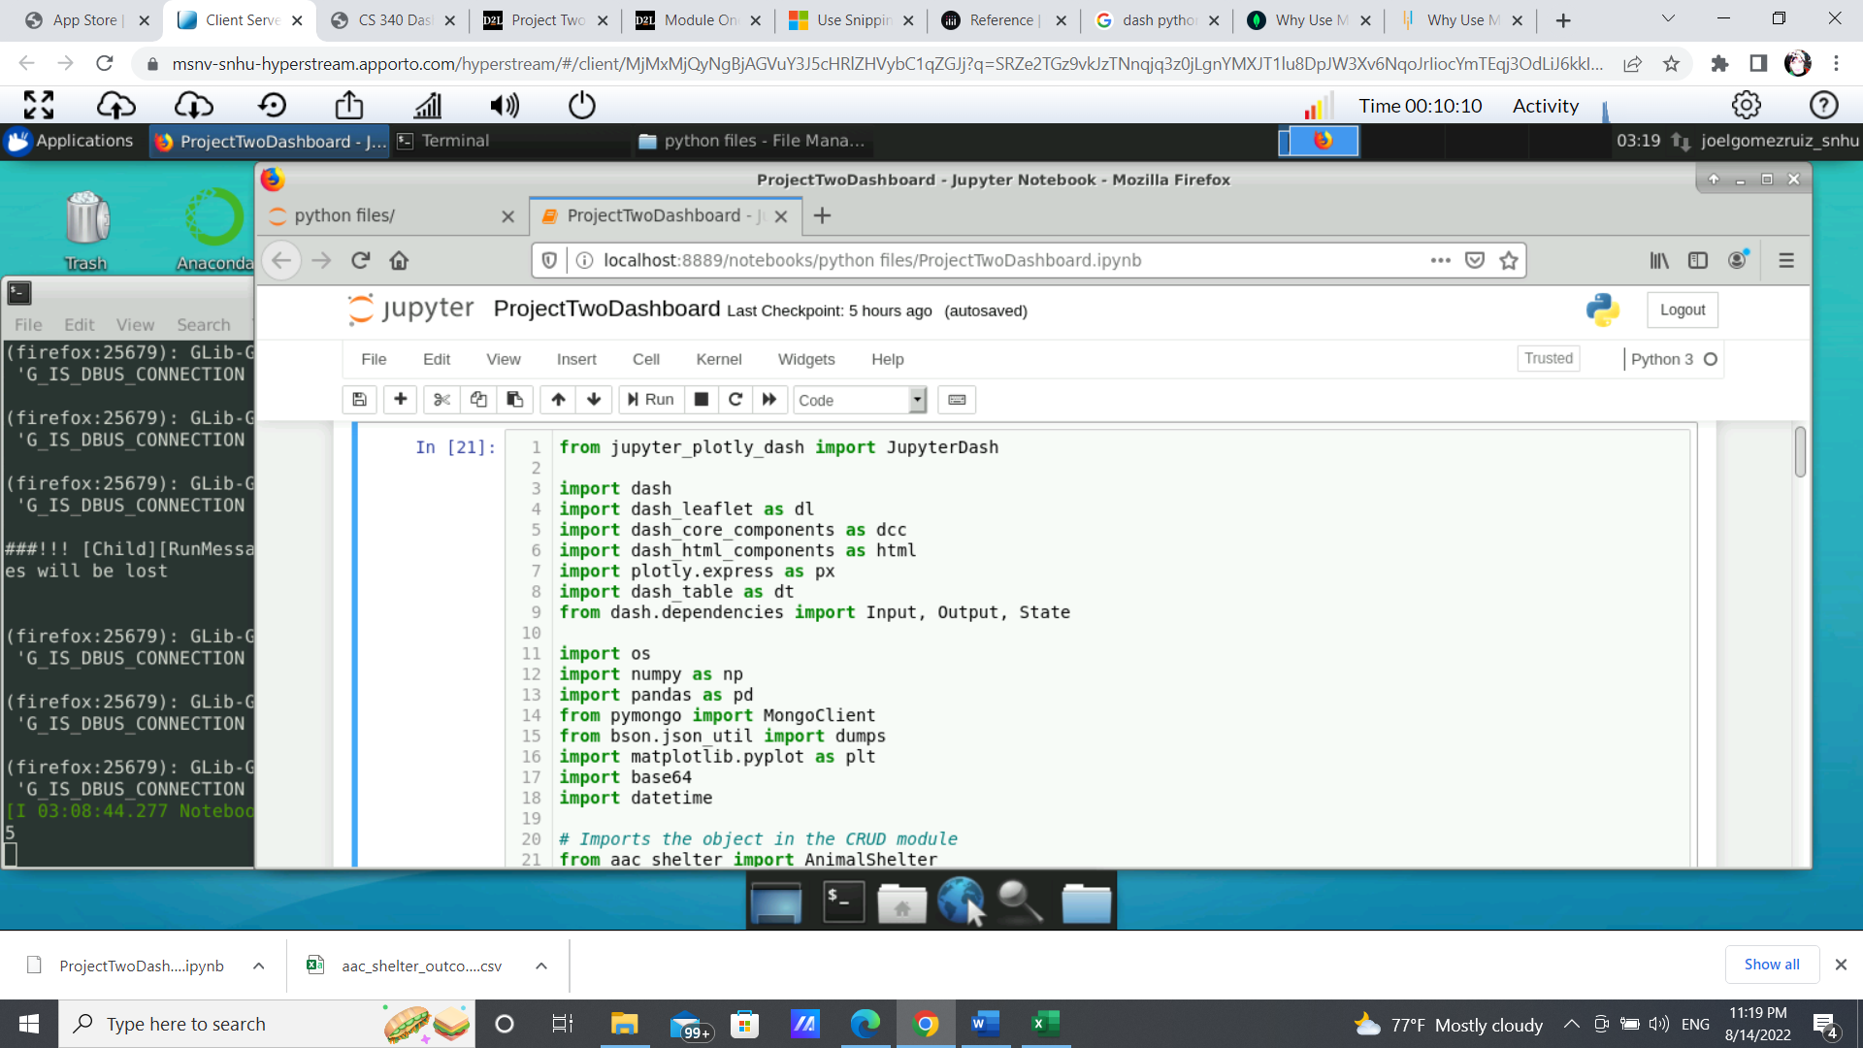

We started MongoDB requiring authentication, which is why it is important to use the user created with the proper roles. With those credentials, an object shelter can be created with all the CRUD capabilities created in the previous project:

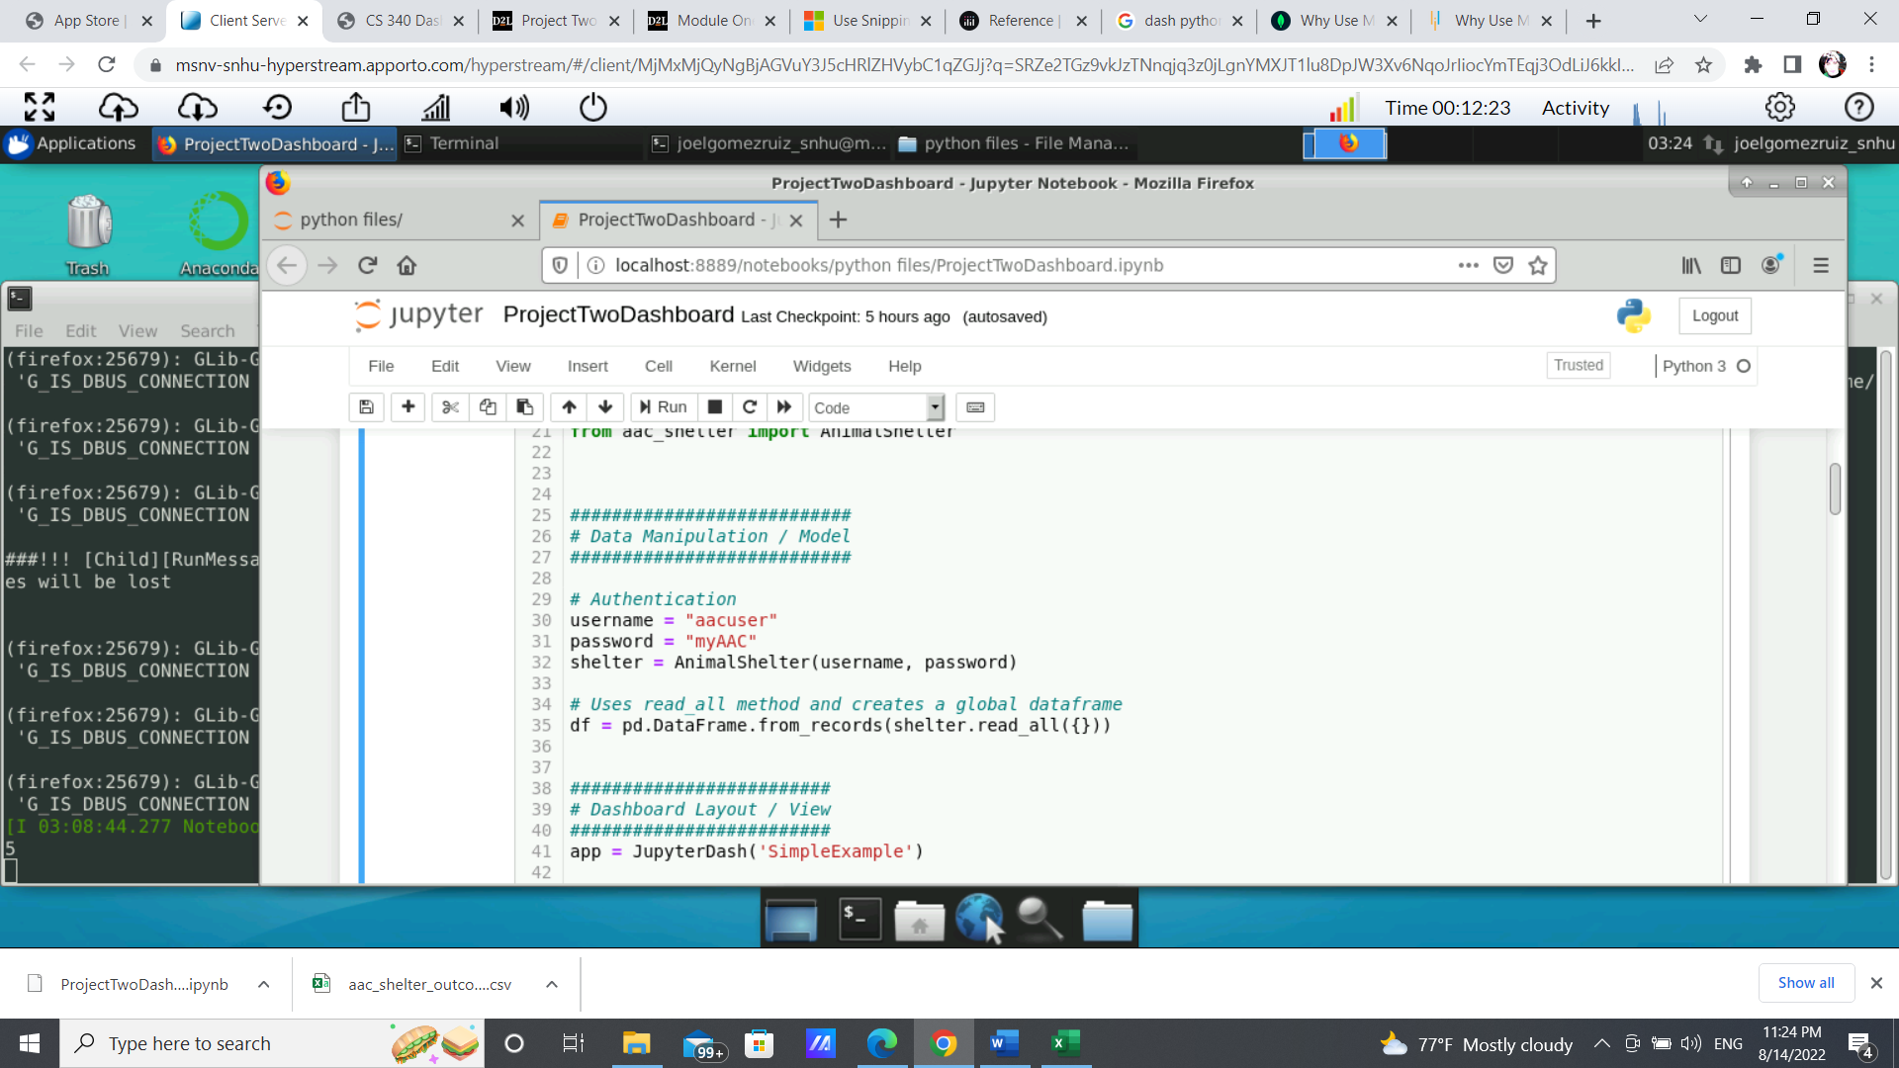

Consider that pandas would be used throughout this code to create the data frame, which can be done using the “read_all” function of the CRUD module:



Start the application using the dash function: 

Once instantiated, the layout is then set, creating all the elements that will be present in the web application. This step is mainly structural and does not provide major functionality or user interactivity.

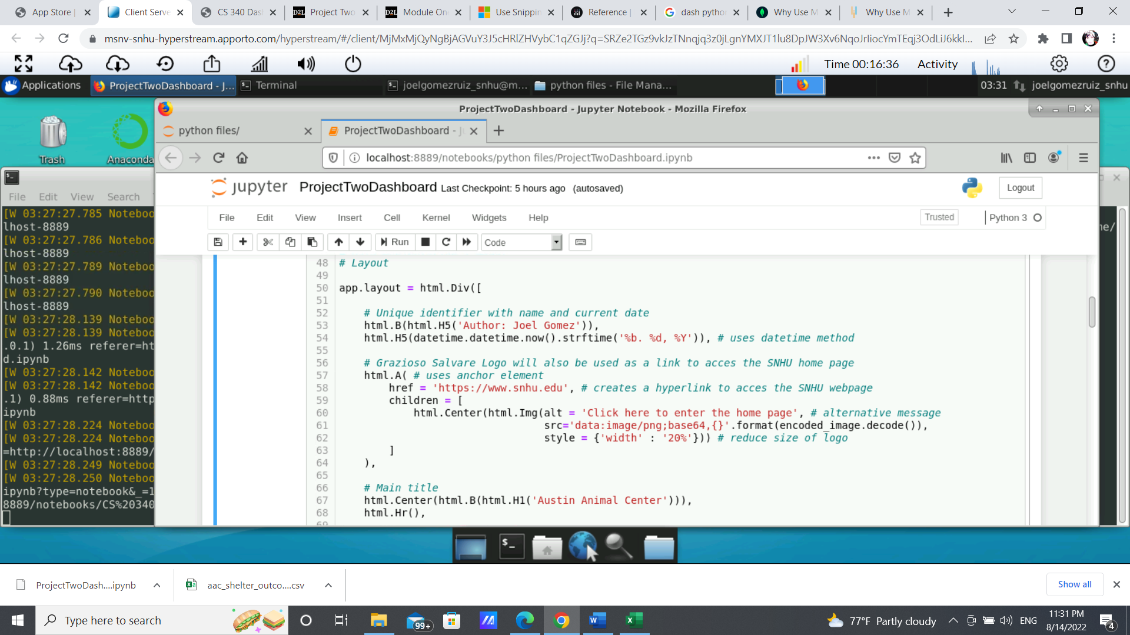

**Headers:** Two unique identifiers were created and set at the top of the dashboard, the first line referencing the name of the author, and the second one the current day of the use of the app.

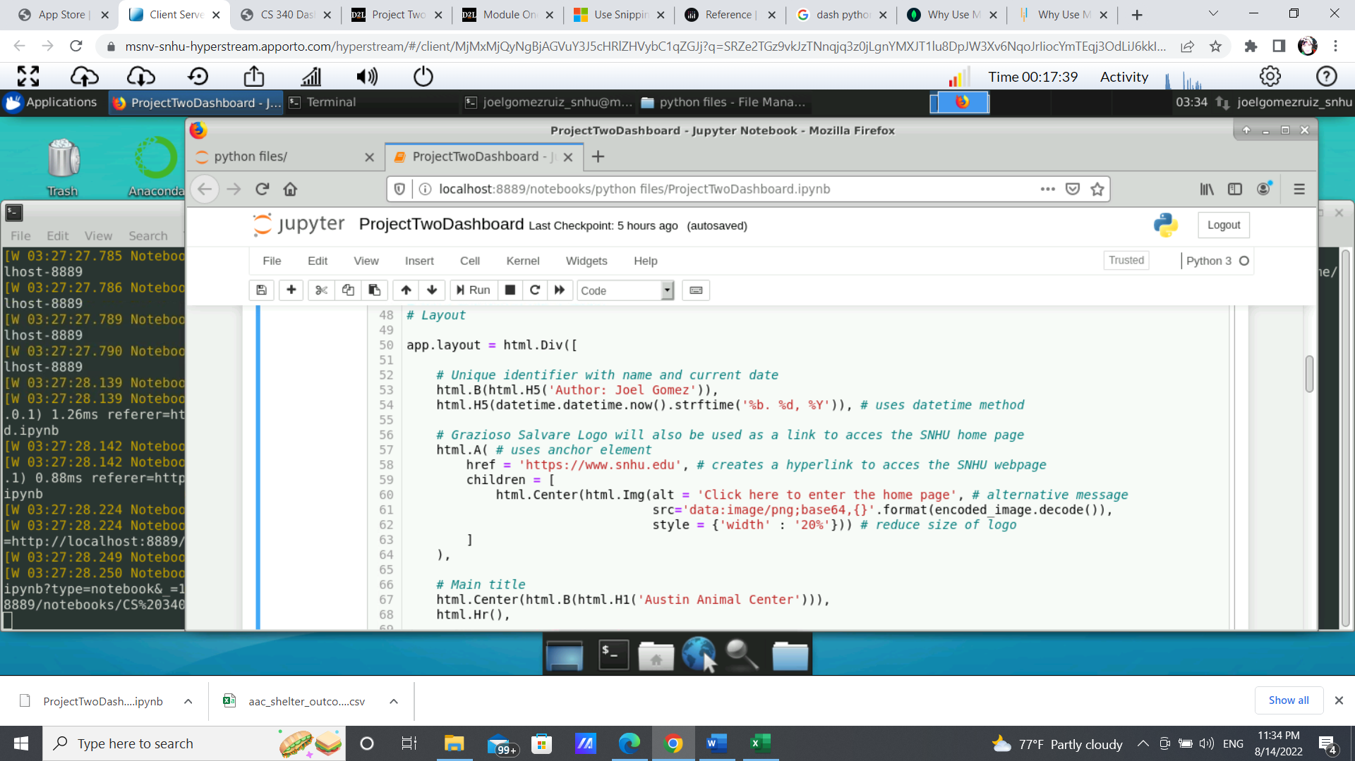

**Logo:** The Grazioso Salvare Logo was required per the client and is positioned at the center of the page. To include the image the following code was required (Note that “Logo.png” is the name of the image file):

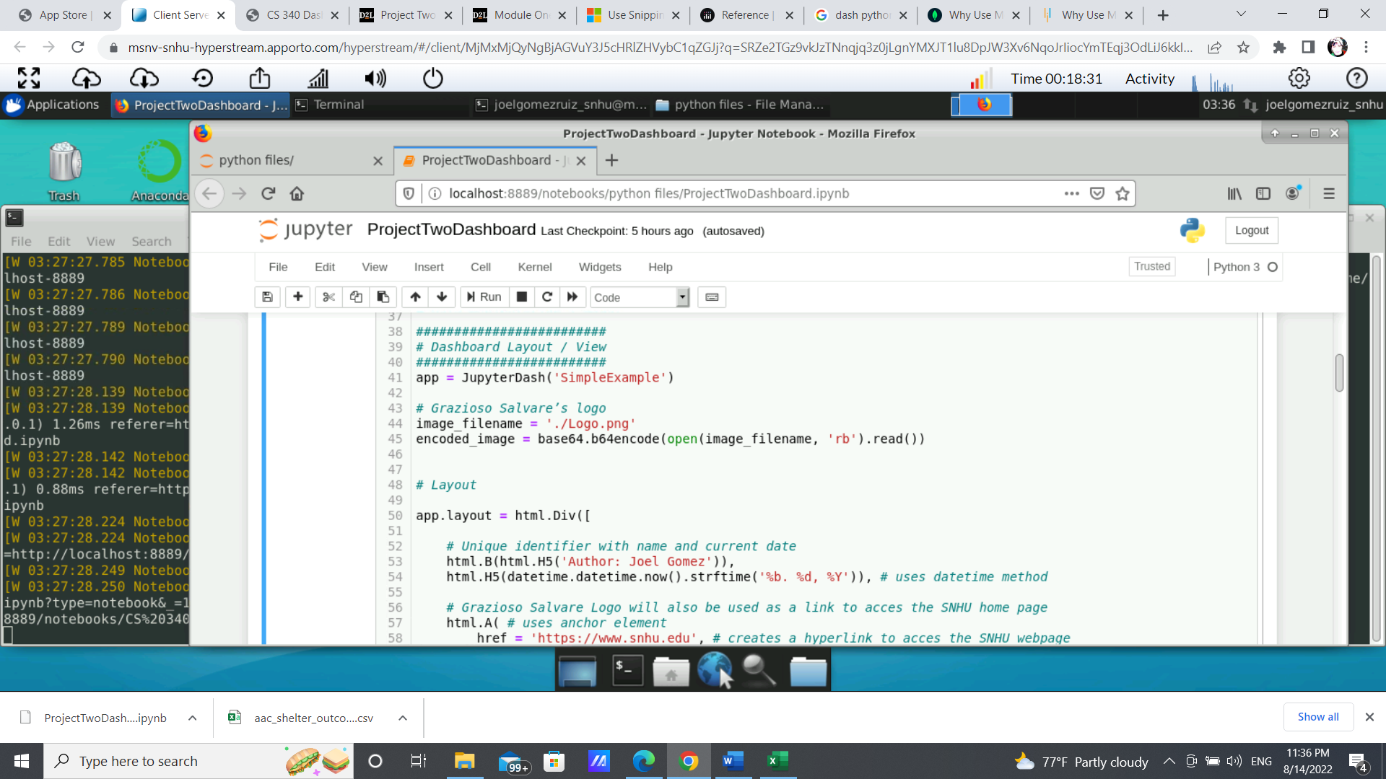

Additionally, this logo would serve as a URL anchor tag to access the SNHU web page. Note that the URL can be updated to any address as desired: 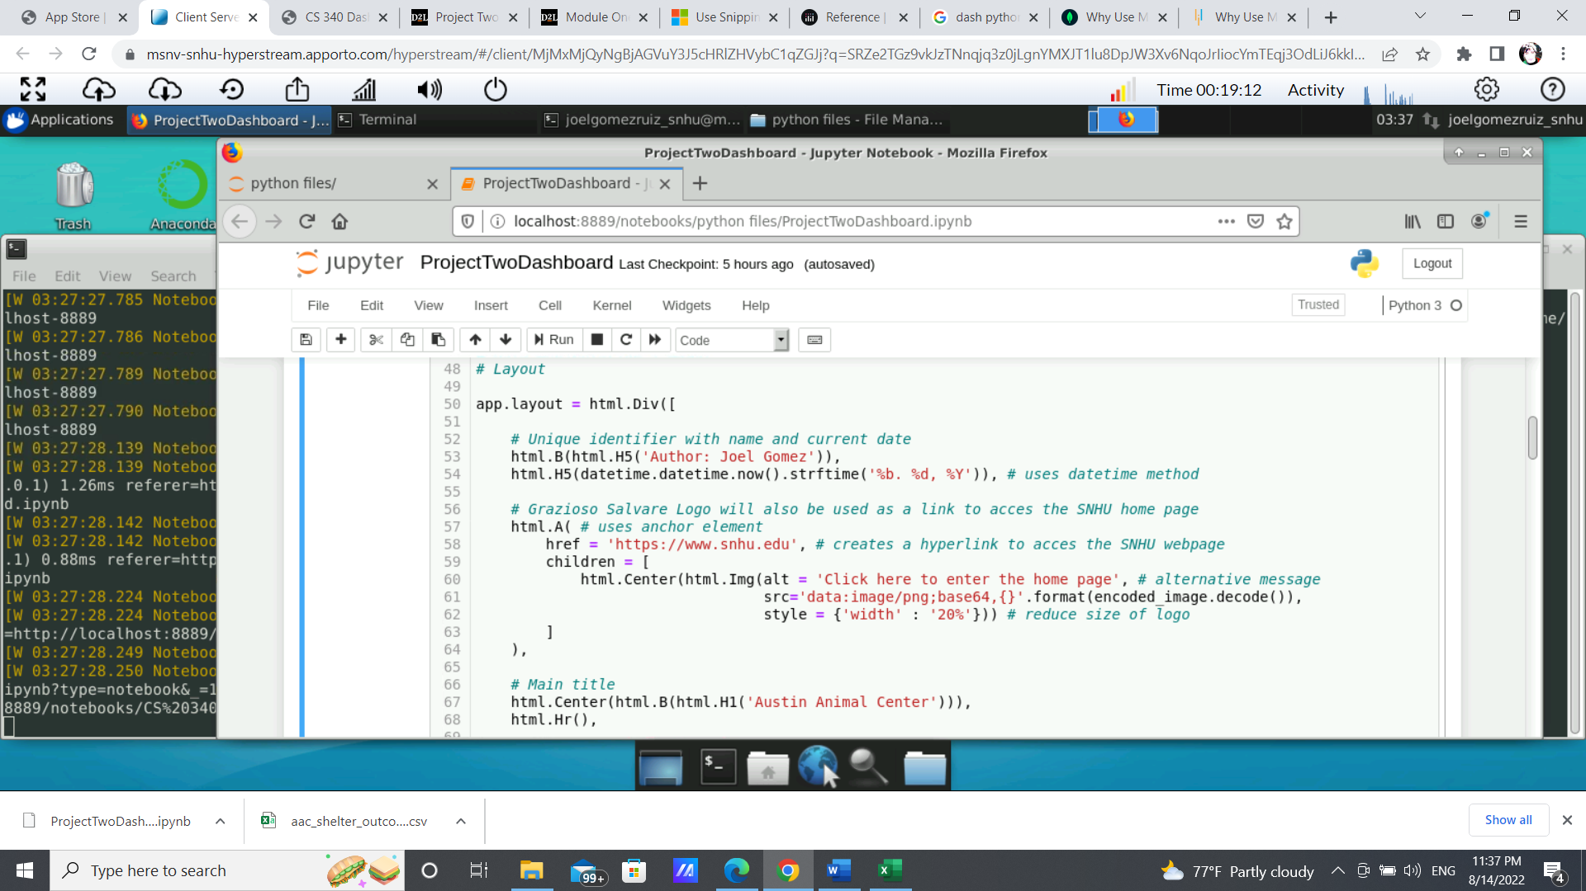

**Data Table:** The following is the main structure of the data table, more properties can be added according to documentation:

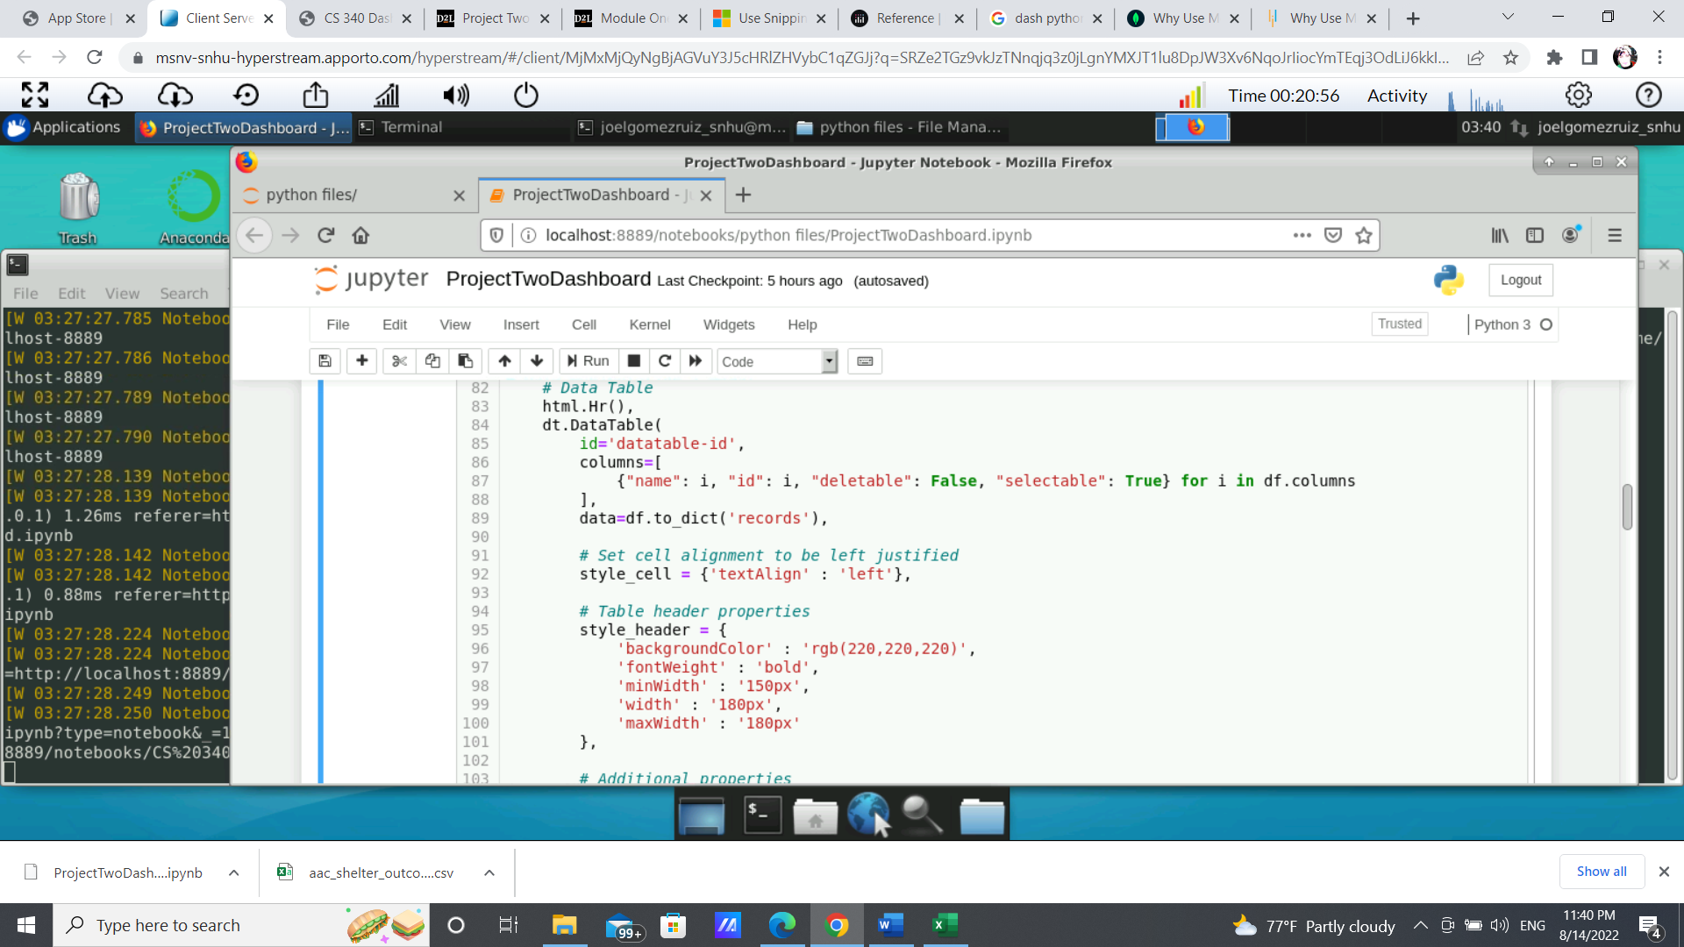

**Pie Chart and Geolocation Chart:** These were set on the same line, so they are displayed side by side:

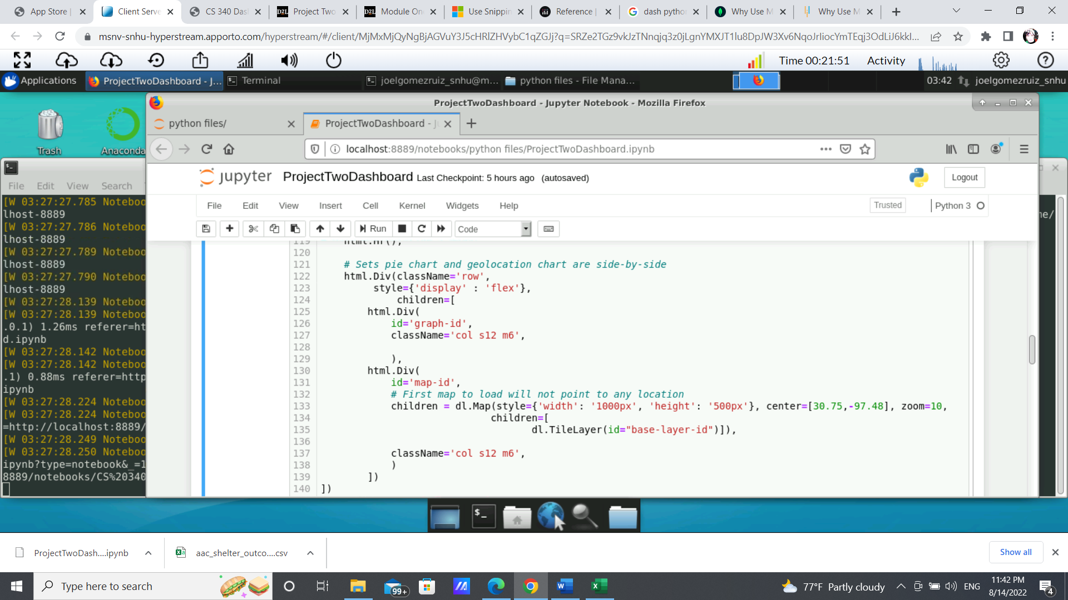

**The Callbacks:** This section defines the different behaviors enabled by user input. Here are shown the code use for filtering and the display of the two graphs:

**Filtering by buttons:** (Note that the parameters criteria can be set as needed)

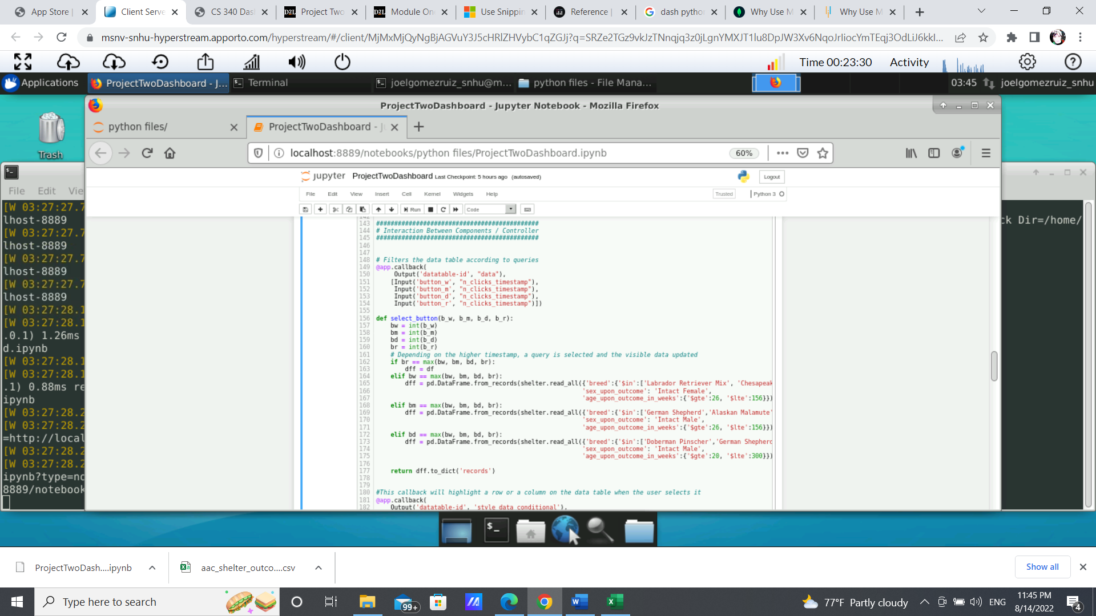

**Pie Chart:**

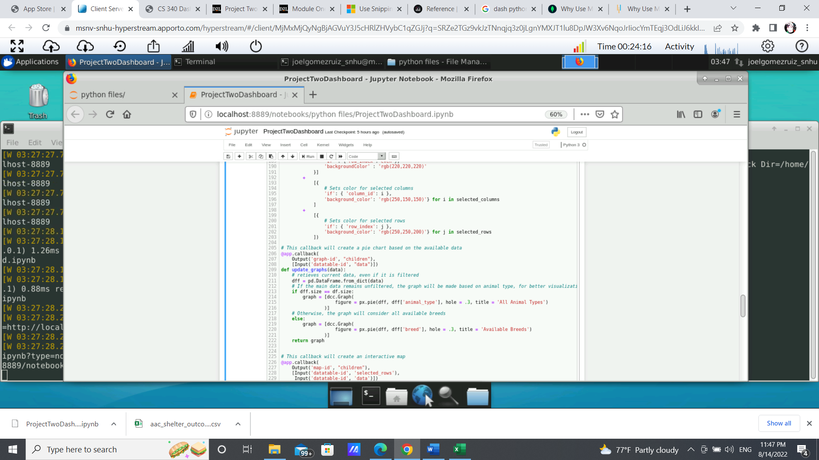

**Geolocation Chart:**

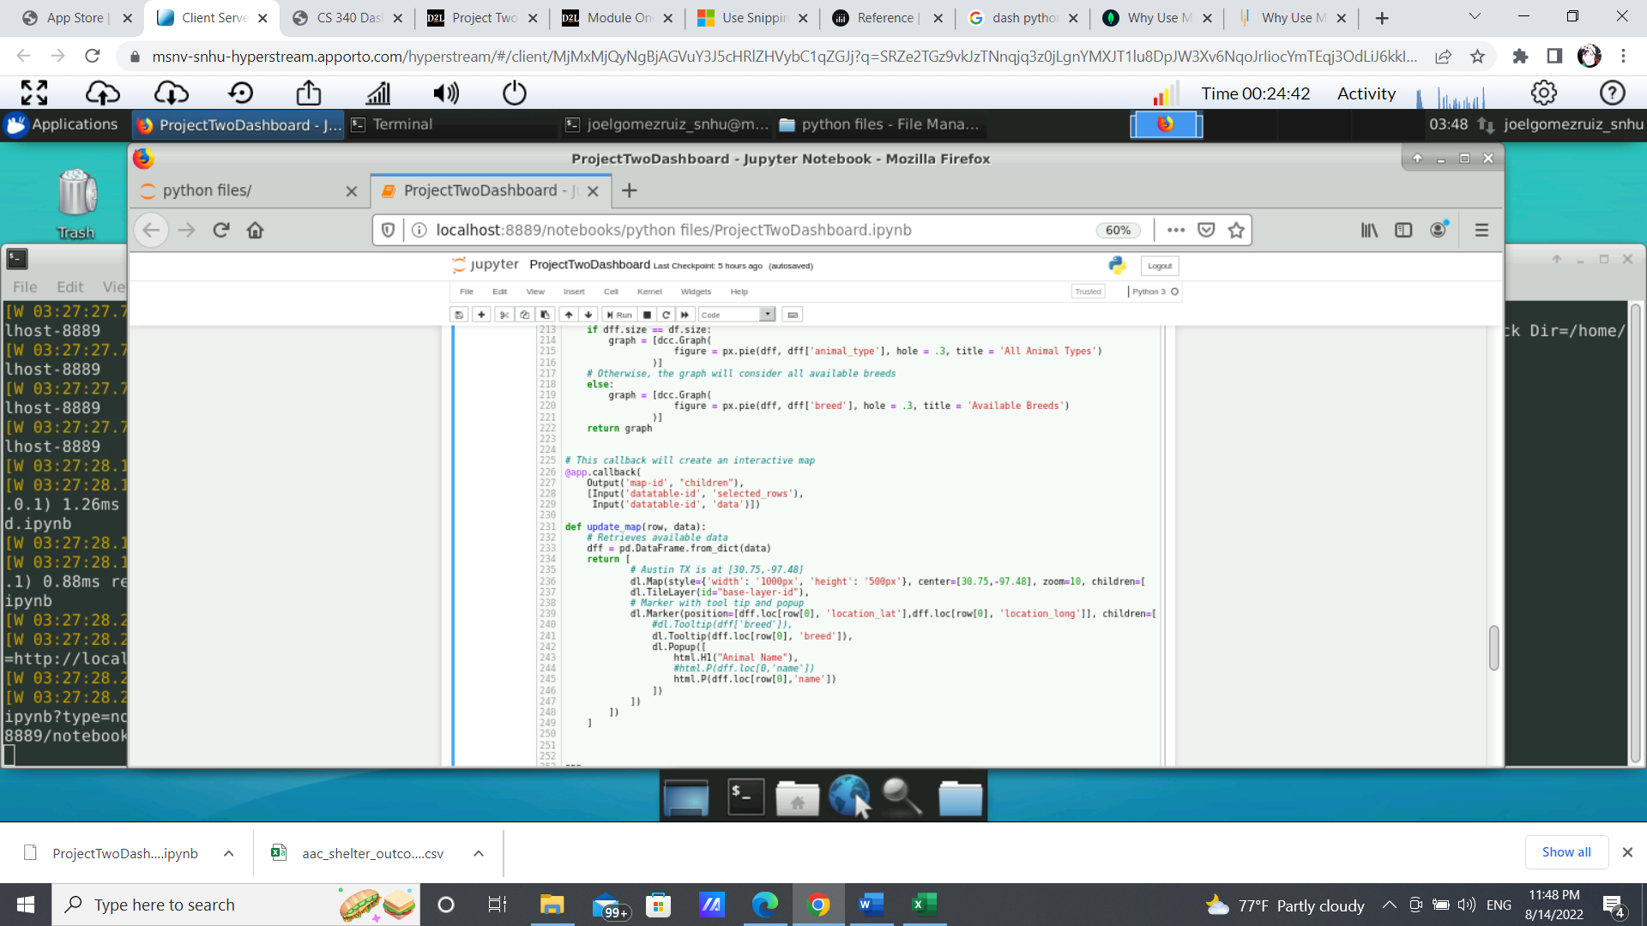

**CHALLENGES:**

This project required the revision of a lot of documentation and analyzing the proper use of dozens of methods with many possible different parameters. The main challenge came when first attempting to understand what each line of code does, but it all comes to make sense by trial and error, testing different methods and different inputs. As an early version of the project, it still meets all the requirements and even provides additional functionality and intractability. However, it is highly suggested to look for different ways that could make this project more efficient in order to increase performance and a better experience to the user.

## Contact

Joel Gomez

Southern New Hampshire University